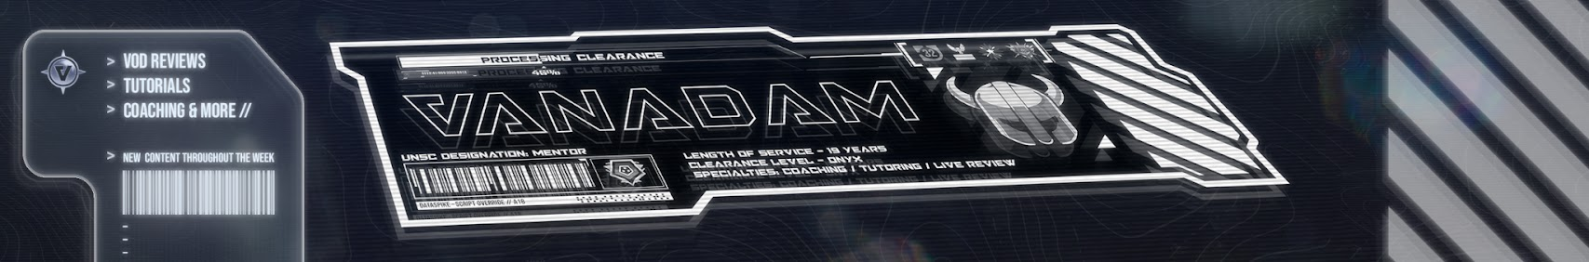
Davis, Adam (Student)
Learn, read, review a website for Halo players to improve their game through interactive opportunities
Vanadam Program
Functional Learning



Foreword
This project was started 30/09/2025, coinciding with the 2nd year of teaching on my MSc Computing (work experience) at Sheffield Hallam University. The modules providing inspiration and guidance on this project included “Essentials in Full-stack Software Development” and “Professional Practices in Software Projects”. These have been supplemented by documentation such as W3 schools and other provider documentation as well as key texts such as the PMBOK the Project Management Book of Knowledge 7th Ed (Project Management Insitute, 2021) and more (see bibliography)
I decided to undertake this program in order to improve my skills but also to improve and expand my existing esports brand “Vanadam Esports” a niche small business focused on helping FPS enthusiasts tied to the Halo ecosystem.
This will encompass different stages of design from a minimum viable product implement enhancements and improvements as the cycle continues.

Contents
Contents
Foreword 1
Contents 1
Project Brief & Outline 2
The Problem 2
Solving the Problems 4
Functional requirements based on problems outlined 5
Non-functional requirements 6
Project Phase 1: Minimum Viable Product 8
Design Research 8
Case Study 1: Icy Veins 8
Case Study 2: Wowhead 9
Case study 3: Mobafire 10
Case Study 4: U.GG 10

Project Brief & Outline
Vanadam Esports is a small but reasonably known brand in the Halo ecosystem. Undertaking shout casting, livestreaming and Video on Demand business through YouTube and other platforms. The business generates revenue through paid services such as coaching and casting but also through sponsorships and viewer add revenue. To further expand the capabilities of the business a website needs to be developed that will allow interaction for both company and end-users with content and resources
provided by Vanadam.

The Problem
The current method that users interact with online content for Vanadam is significantly impacted by the limitations of the VoD platforms used. For example, Youtube limits the way videos can be found of filtered within a channel and users have reported that “they find it difficult to find specific video content for their chosen map and mode”. Previous consultation has shown that a “review list” was made in the community Discord server which solved this problem but very crudely.
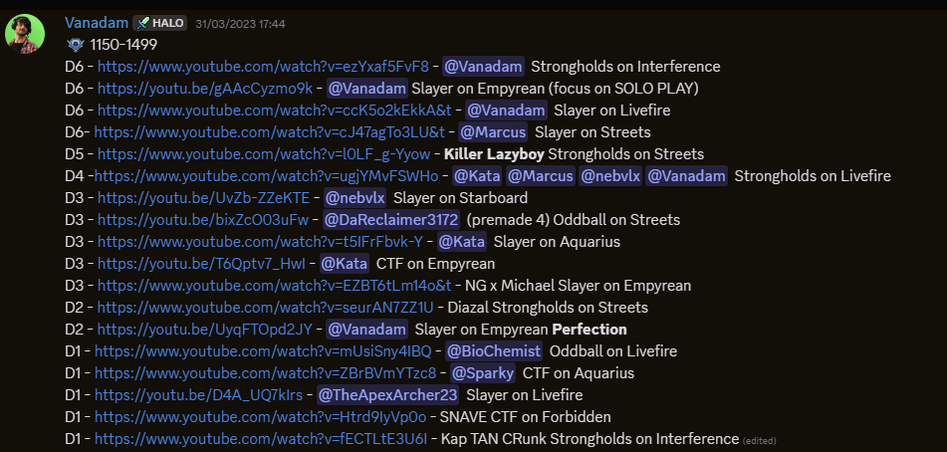
Discord post of “VoD Review Library
YouTube comments of community members attempting to make coaching reviews easier to find
Community members are unsure which content would be most beneficial as the availability of certain combinations is obfuscated by YouTube methods
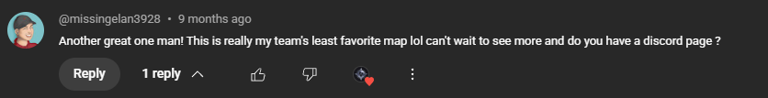

Users can’t find information on the services offered by the business easily due to YouTube profile format and options and are confused how to submit or interact
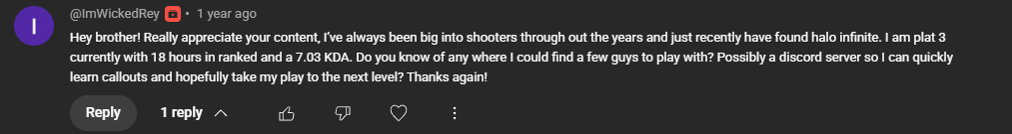
Users want a community space where they can interact with others, find groups or learn.

In addition, there have been requests from customers for a better way to engage with private tuition (coaching) and find articles written in collaberation with other community members of the Halo ecosystem.

Solving the Problems

Problem 1: Users struggle to find, quantify, search and see available content
The project will deliver a method to store, search and filter available content from Vanadam or other collaborating creators on the website. Users will be able to do this for video content, article content and be able to set custom filters for criteria such as game, map, mode and match rank.
Functional item | Requirements
Video database | SQL logic and table
Query methods to identify videos | SQL logic and flask endpoint
Suitable webpages for videos and articles than generate dynamically | HTML / CSS / bootstrap / Flask

Problem 2: Users can’t find information on the services offered by the business
The Project will act as a central hub for all services and resources for customers/users to find where any offered products or services will be accessible through menus and navigation options including the ability to submit a match for review via a form, submit a request for private coaching via another form, easily access information on these services through dedicated web pages.
Functional item | Requirements
YouTube video review form | HTML / CSS / Flask endpoint / SQL logic and tables
Coaching requests form | HTML / CSS / Flask endpoint / SQL logic and tables
Business information | HTML / CSS / bootstrap / Flask

Problem 3: Users want a community space where they can interact with others, find groups or learn.
The Project will deliver a personalised experience where users can access learning content such as videos and articles but moreover will allow users to set profile flags that they can use to post on a looking for group, looking for team message board that will allow them to find other players and play with and learn with.
Functional item | Requirements
User profile | SQL logic and table, authentication, protection, hashing.
Looking for group / team message board | SQL logic and flask endpoint
Suitable webpage | HTML / CSS / bootstrap / Flask

Functional requirements based on problems outlined
Group | function | Explanation
User Profiles | Log in | Start a session
 | Log out | End a session
 | Profile Page | User has a viewable profile page with data fields they can enter (name, Xbox live tag, rank, time zone, languages spoken)
 | Edit profile (text based) | Set public facing info to help communicate with other users
 | User group allocation | Admin / Public user groups
 | My actions | Users have a log of any actions on the website they have done such as coaching submissions or review requests as well as viewed videos
Videos | SQLite table | Store video data from the YouTube API v3 using API key and scraping data from the @VanadamYT channel.
 | Query logic | Search for videos by map, mode, topic, game, rank of match and upload date
 | Play YT videos on website | Use YouTube embed to deliver webpages with content on website
Articles | SQLite table | Store article data from articles entered on the site
 | Query logic | Search articles by map, mode, topic, game, rank of match and upload date
 | Deliver dynamic article pages | Use SQL data to generate banks of articles that update as more articles are added to the database
 | Adding articles | Articles can be added to the db on the backend and load content into a template html
Maps | Collate and serve information | Users can access a “Map” page for each map in the game that delivers a filtered assortment of articles and videos based on the map selected
Message Board | Submit message | Users can submit a looking for group (LFG) message on the board (xbox name, rank, mode, timezone, language)
 | Edit message | Users can edit a looking for group (LFG) message on the board
 | Filter message | Users can filter messages based on the rank, mode, time zone, language) criteria
Services | Submit review form | Users can submit a form containing information about a coaching request (game URL link, rank, map, mode, youtube video link)
 | Submit coaching form | Users can submit a form containing information about a coaching session request ()

Non-functional requirements
- Intuitive design that is easy to use
- Scalable (1000+ users)
- Modular design where features can be enabled or disabled
- Secure data storage (hashing)
- Reasonable loading speed utilizing efficient file sizes (<1s)

Users can register on db
Test 1 #connected to database but no user registered
Test 2 #print statement used to track ‘/register’ form isnt validating on submission
Test 3 #

Project Phase 1: Minimum Viable Product
The minimum viable product will be:
- A brand coherent website
- Users can access all socials through the website.
- Users can browse articles around Halo.
- Users can filter and view videos from YouTube.
Logging in and custom user tools are not within the scope of MVP. The design of the website should still be modular such that areas can be expanded or tied together as more features are added.

Design Research

Case Study 1: Icy Veins
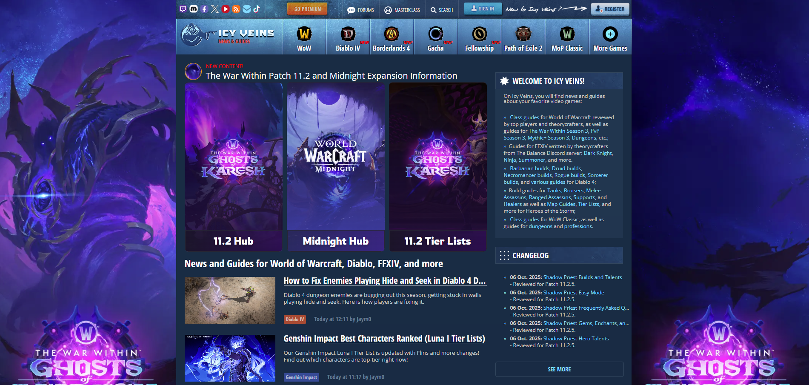
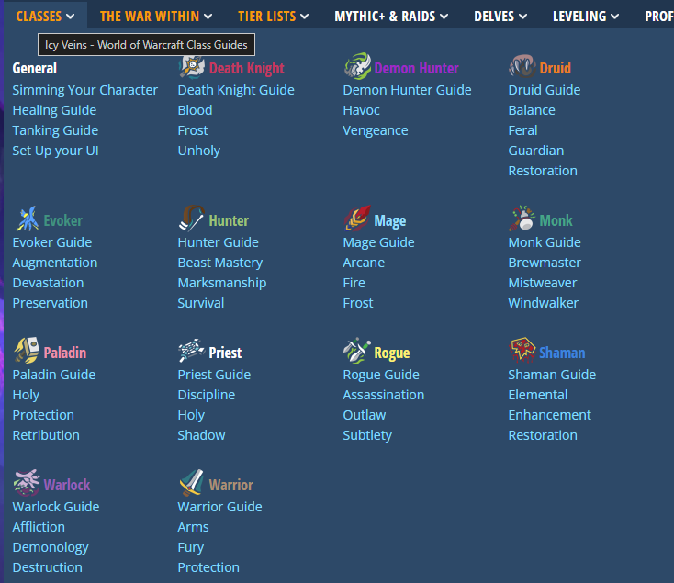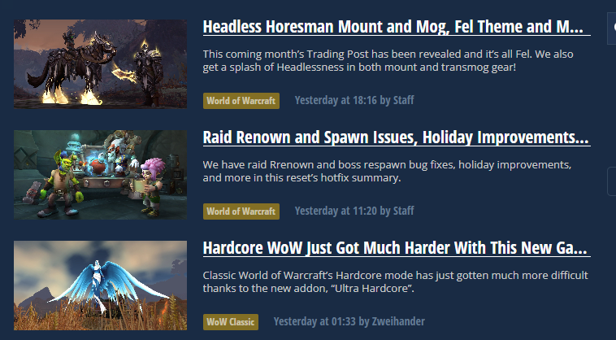

Case Study 2: Wowhead
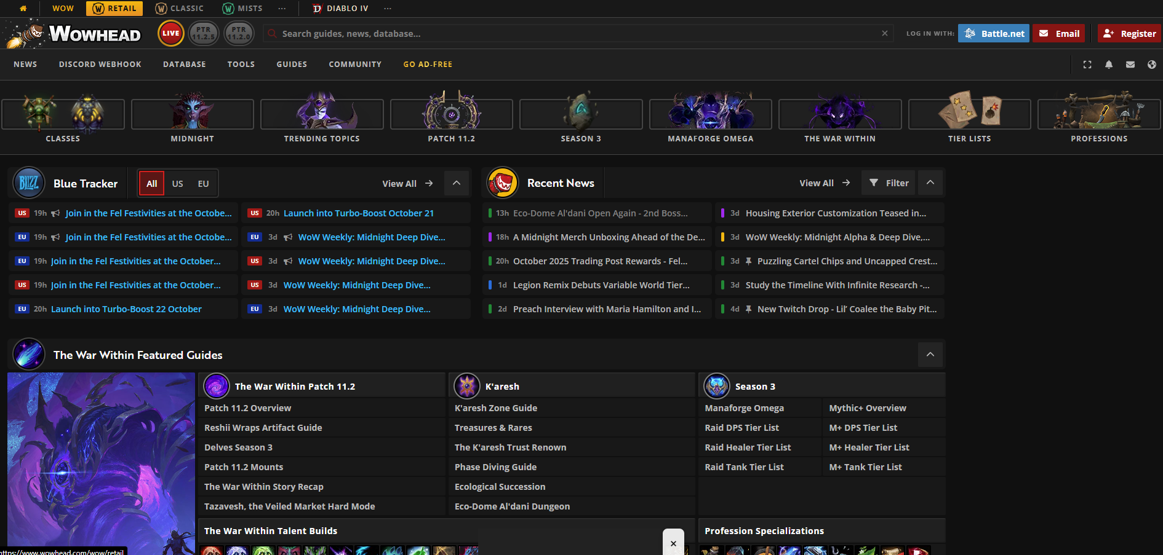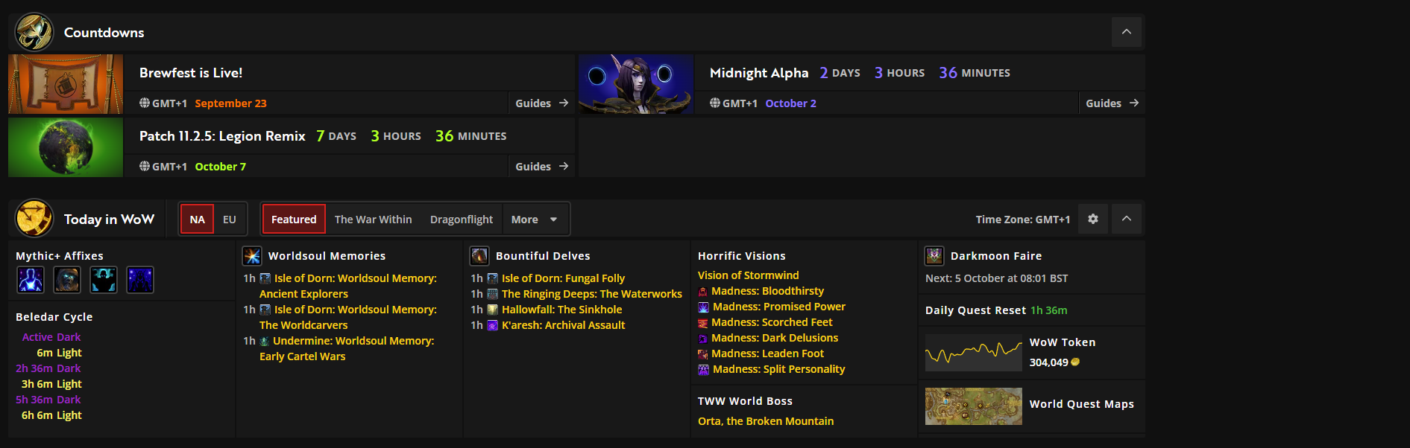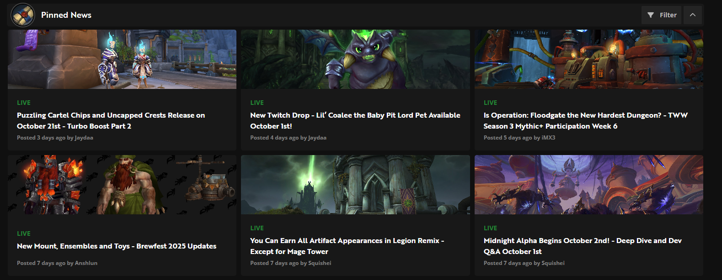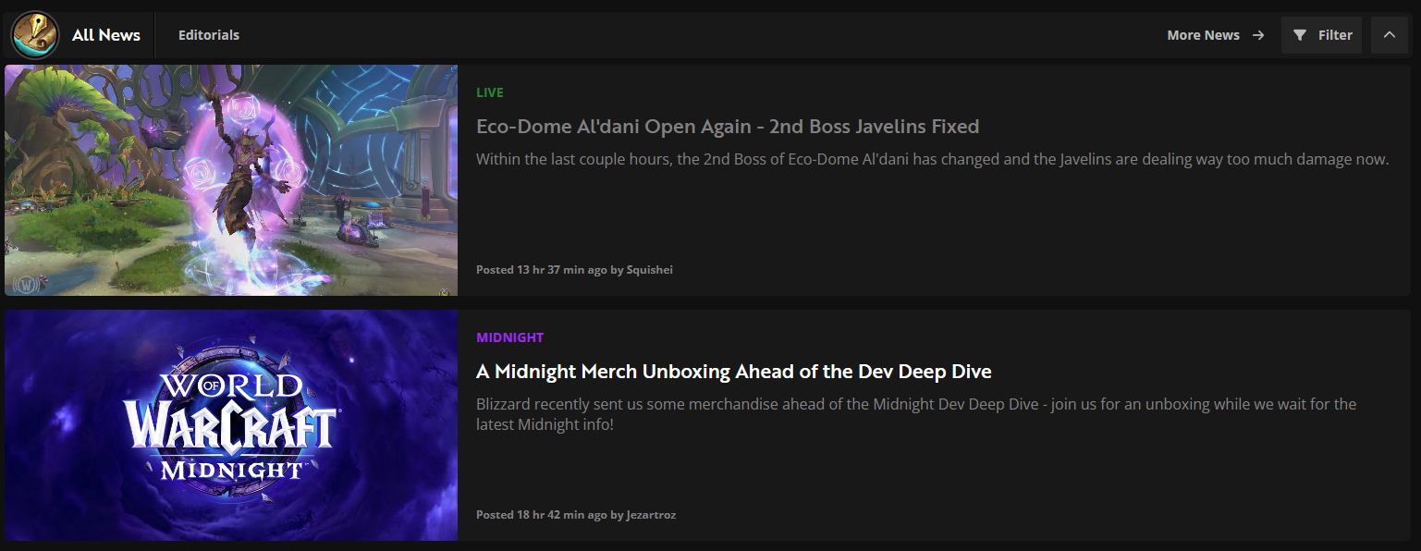

Case study 3: Mobafire
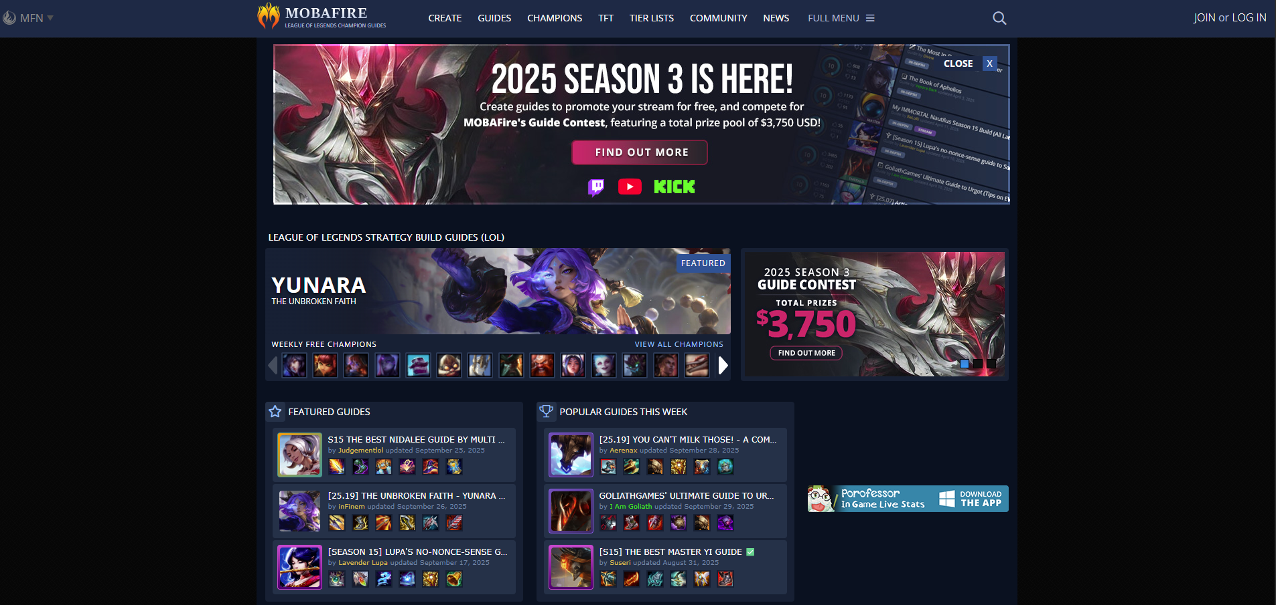

Case Study 4: U.GG
